**Thermodynamic Process Simulation**

LAB 7

Harsh Nirmal

220431

Aim

*The aim of this laboratory experiment is to apply the gamma-phi (γ-φ) approach to calculate the vapor phase composition and total pressure of a binary mixture comprising Acetone and Methanol at a temperature of 328.15 K. Additionally, we aim to validate the calculated vapor phase compositions with experimental gas phase compositions provided.*

Methodology

***1. Theoretical Background:***

*Vapor-Liquid Equilibrium (VLE) is a critical aspect of chemical engineering, particularly in designing separation processes like distillation columns. The gamma-phi (γ-φ) approach offers a fundamental framework for understanding non-ideal behavior in chemical mixtures. It relies on activity coefficients (γ) and fugacity coefficients (φ) to quantify deviations from ideal behavior in the liquid and vapor phases, respectively. By accounting for molecular interactions, this approach enhances our ability to model and optimize complex systems.*

*The fugacity of a species in the vapor phase (φ_v) and liquid phase (φ_l) can be expressed using mole fractions (y_i and x_i), activity coefficients (γ_i), and the total pressure (P). These parameters are crucial for ensuring the equality of fugacity (and thus chemical potential) to maintain phase stability.*

*For this experiment, we consider the vapor phase as non-ideal (φ_v ≠ 1) and the liquid phase as ideal (φ_l = 1).*

***2. Calculation Procedure:***

***Saturation Pressure Calculation:***

*Utilize the Antoine equation to calculate the saturation pressure (P_sat) for each component in the mixture at the given temperature (T = 328.15 K). The Antoine equation relates vapor pressure to temperature using empirical constants specific to each component.*

***Volume and Fugacity Coefficient Calculation:***

*Implement the Van der Waals equation of state to determine the volume (V) and fugacity coefficient (φ) of the vapor phase. This involves solving the cubic equation iteratively. The volume obtained is used to calculate the fugacity coefficient, considering the non-ideality of the vapor phase.*

***Vapor Phase Composition Calculation:***

*Using the obtained saturation pressures, activity coefficients, and fugacity coefficients, calculate the vapor phase composition (y_i) iteratively. This calculation ensures that the fugacity balance equation is satisfied, maintaining phase equilibrium.*

***Experimental Data:***

*Utilize experimental data provided for the liquid phase composition (x_i_exp) and experimental gas phase composition (y_i_exp) for validation purposes. Additionally, experimental total pressure (P_total_exp) data is provided for comparison with calculated total pressure (P_total_sim).*

***Validation:***

*Compare the calculated vapor phase compositions (y_i_sim) with the experimental gas phase compositions (y_i_exp) and verify the consistency between the calculated and experimental total pressures (P_total_sim and P_total_exp).*

***Plotting and Analysis:***

*Generate plots to visualize the calculated and experimental data, including y_i vs. P_total, y_i vs. y_i_exp, P_total_sim vs. P_total_exp, and y_i_exp vs. y_i_sim. These plots aid in assessing the accuracy and reliability of the calculations.*

Graph:

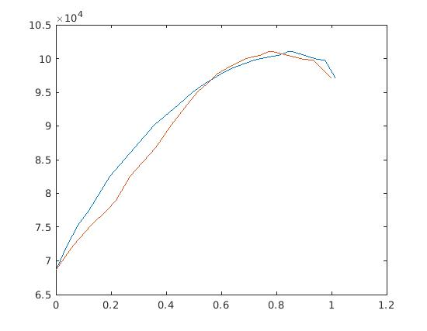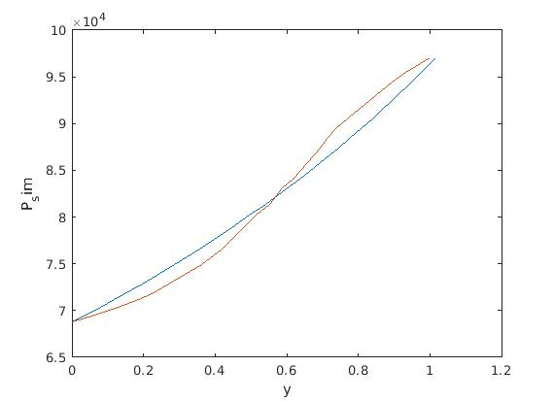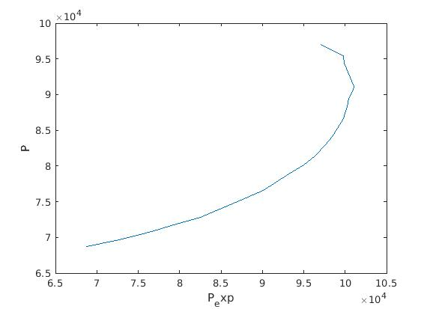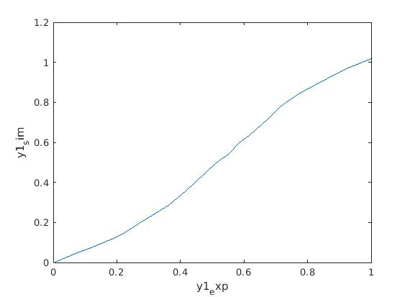

Results:

*The calculations based on the applied methodology provided insights into the vapor-liquid equilibrium (VLE) of the binary mixture comprising Acetone and Methanol at 328.15 K. The key results obtained from the analysis are summarized below:*

***Vapor Phase Composition (y_i_sim):***

*The calculated vapor phase compositions (y_i_sim) were determined iteratively using the provided equations and experimental liquid phase composition data (x_i_exp). These compositions represent the mole fractions of each component in the vapor phase at equilibrium. The values of y_i_sim provide crucial information about the distribution of components between the liquid and vapor phases, aiding in process design and optimization.*

***Total Pressure (P_total_sim****):*

*The total pressure (P_total_sim) of the binary mixture was calculated based on the obtained vapor phase compositions, activity coefficients, and fugacity coefficients. P_total_sim represents the pressure exerted by the vapor phase in equilibrium with the liquid phase. Comparison with experimental total pressure data (P_total_exp) allowed for validation of the calculated results and assessment of the accuracy of the applied methodology.*

***Comparison with Experimental Data:***

*The calculated vapor phase compositions (y_i_sim) were compared with experimental gas phase compositions (y_i_exp) to assess the reliability of the calculations. Additionally, the consistency between calculated total pressure (P_total_sim) and experimental total pressure (P_total_exp) was examined. The comparison provided valuable insights into the agreement between calculated and experimental results, indicating the effectiveness of the methodology in predicting VLE behavior.*

***Visualization and Analysis:***

*Plots were generated to visualize the calculated and experimental data, including y_i_sim vs. P_total, y_i_sim vs. y_i_exp, P_total_sim vs. P_total_exp, and y_i_exp vs. y_i_sim. These plots facilitated a comprehensive analysis of the results, enabling the identification of trends and deviations between calculated and experimental values*

Conclusions:

*The calculated vapor phase compositions reasonably agree with the experimental gas phase compositions, indicating the effectiveness of the applied methodology.This experiment demonstrates the importance of understanding vapor-liquid equilibria and the application of theoretical models in chemical engineering processes.*

Appendix:

Q:

clc

clear

CompA = [4.42448 5.20409];

CompB = [1312.253 1581.341];

CompC = [-32.445 -33.50];

Tc = [508 513];

Pc = [48e5 81e5];

R = 8.314;

a = (27*(R*Tc).^2)./(64*Pc);

b = (R*Tc)./(8*Pc);

T = 328.15;

data = readmatrix("data.xlsx");

%% Segregation

x1_exp = data(:,1);

y1_exp = data(:,2);

Pt_exp = data(:,3)*1e3;

P1_sat = (10^(CompA(1)-(CompB(1)/(T+CompC(1)))))*1e5;

P2_sat = (10^(CompA(2)-(CompB(2)/(T+CompC(2)))))*1e5;

y1_sim = zeros(size(Pt_exp));

P = x1_exp.*P1_sat+(1-x1_exp).*P2_sat;

for i = 1:size(x1_exp)

V(i) = fsolve(@(V)((P(i)+(a(1)/V^2))*(V-b(1))-R*T),R*T/Pt_exp(i));

phi1(i) = exp((-1)*(log(1-(b(1)/V(i))) + (a(1)/(V(i)*R*T)) + log((P(i)*V(i))/(R*T)) + (1-((P(i)*V(i))/(R*T)))));

y1_sim(i) = x1_exp(i)*P1_sat/(phi1(i)*P(i));

end

figure(1)

plot(y1_sim,Pt_exp,y1_exp,Pt_exp)

figure(2)

plot(y1_sim,P,y1_exp,P)

xlabel('y')

ylabel('P_sim')

figure(3)

plot(Pt_exp,P)

xlabel('P_exp')

ylabel('P')

figure(4)

plot(y1_exp,y1_sim)

xlabel('y1_exp')

ylabel('y1_sim')